**Aggregation**

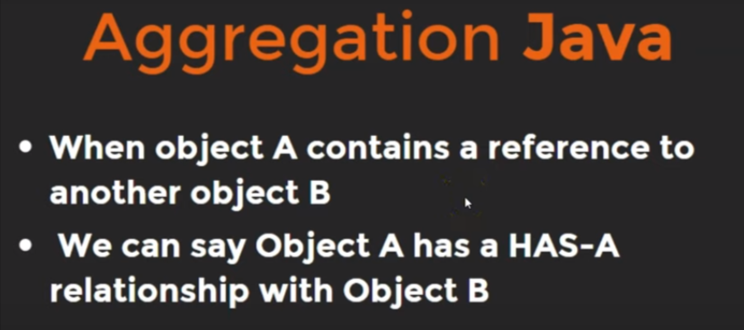

Process of initialization of a class like a variable inside another class called Aggregation.

**Example:**

class Address{

String HouseNo,

City,

Country;

public Address(String houseNo, String city, String country){

this.HouseNo = houseNo;

this.City = city;

this.Country = country;

}

}

class Employee{

String name;

// Here, type of address is Address

Address address;

public Employee(String name, Address address){

this.name = name;

this.address = address;

}

public void displayDetails(){

System.out.println(name + " " + address.HouseNo + " " + address.City + " " + address.Country);

}

}

public class Main {

// main Method

public static void main(String[] args) {

Address ad1 = new Address("H.N-105", "Bokaro", "India");

Employee emp1 = new Employee("Chandan", ad1);

emp1.displayDetails();

}

}

**Output:**

Chandan H.N-105 Bokaro India